[H1] What is IoT?
Dek: A definition and key context
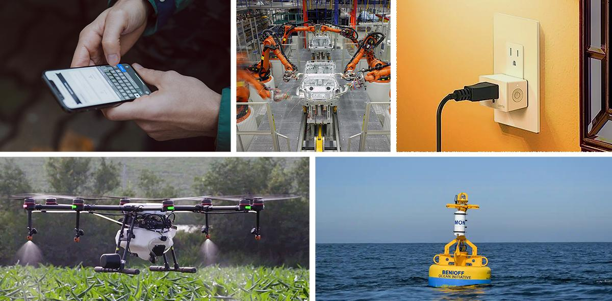
CAPTION: Photos from left, clockwise: Unsplash, Wikimedia Commons (CC BY-SA 3.0), © Belkin, Bekah Lane © The Marine Mammal Center, © DJI. Used with permission.
Internet of things (IoT) refers to networks of devices (“things”) that can connect and share data. IoT is not a single technology, but a category of them, including a growing number of applications. They can use devices ranging from personal fitness trackers to industrial equipment, such as thermostats or assembly robots.
IoT applications are defined not by what they are but by what they do, so whether a technology is part of the IoT depends on how it is used. IoT applications sense an environment, then share, process, and act on that information. The particular hardware is not as relevant as the process it contributes to. The “things” can be almost anything, as long as they connect and enable the application.

[H2] Why is it called IoT?
The term “internet of things” was coined in 1999 by Kevin Ashton, a researcher in radio-frequency identification (RFID) technology. Ashton used the term to refer to RFID-tagged products and equipment that could be tracked electronically to make logistics simpler, and soon co-founded the Auto-ID Center at MIT to research and develop RFID and other IoT technologies. The term was quickly applied more generally to the concept of sensing, computation, and communication functionality in ordinary objects.
Despite its name, the IoT does not actually require the internet, just a connection among multiple devices. Such a connection is called a network. There is no single global network called the IoT. Instead, there are many potential networks of all sizes which experts loosely and collectively refer to as the “internet of things.” Some IoT applications do connect to the internet, while others connect to one another on privately operated networks. Some IoT applications still include RFID. Many now connect over Wi-Fi or cellular networks.

[H2] How IoT overlaps with other technologies
IoT intersects with many other cutting-edge technologies: IoT networks use modern telecommunications to connect, and the data they collect enables many other technologies.
For example, 5G, the latest generation of wireless cellular communication systems, enables faster wireless communication and allows more devices to communicate within the same area, fueling larger IoT applications. And as IoT networks gather more data, it may require big data analytics or artificial intelligence techniques to interpret.

IoT is often a key part of digital twins, virtual representations of physical objects or systems. An IoT network of sensors on a real-world object can collect and transmit data to the twin.

IoT networks can also present major cybersecurity risks. IoT devices can be difficult to update and may be placed in hard-to-access locations, so many still run outdated, vulnerable software. IoT devices can also be more prone to physical tampering than traditional computers, opening a new way for attackers to access a network. These threats can be mitigated with a good cybersecurity strategy, but not all organizations understand the unique security challenges of IoT.

[H2] Why is IoT relevant now?
Sensors, microchips, antennas, and other hardware are all getting smaller, cheaper, and more powerful. Wireless communication methods are faster and more reliable. Automation techniques are better established. As the number of IoT applications steadily grows, industry groups have started making standards for how devices communicate and interact with each other. It’s easier than ever for organizations to make and use “smart” devices that can sense, process, share, and act on data.

It’s now common for automobiles to gather and share data, and for industrial equipment as well as home appliances to be programmable and connected. Today, IoT is less a distinctive paradigm in its own right, and quickly becoming a standard part of modern infrastructure. These connections are here to stay.

